Introduction

After accidentally kicking the button on my power strip in the middle of a build process, I spent the better part of two hours tracking down all of the corrupted temporary files on my system to fix this fun little error:

Could not load file or assembly 'Antlr3.Runtime' or one of its dependencies. The parameter is incorrect. (Exception from HRESULT: 0×80070057 (E_INVALIDARG))

Since I never want to have to do that again, I went ahead and created a quick little program to clear them all out for us:

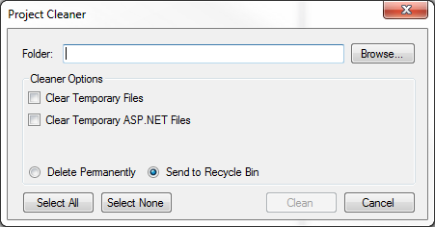

General Use

1. Select a folder using “Browse.” Your selection will appear in the “Folder” text field.

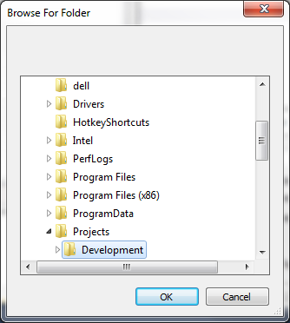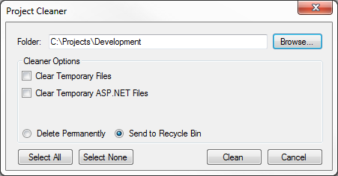

1. Choose any appropriate options:
   1. **Clear Temporary Files**: Removes all files and folders from your machine’s %TEMP% directory
   2. **Clear Temporary ASP.NET Files**: Removes all files and folders from your machine’s temporary ASP.NET directories:

C:\Windows\Microsoft.NET\Framework\v4.0.30319\Temporary ASP.NET Files

C:\Windows\Microsoft.NET\Framework64\v4.0.30319\Temporary ASP.NET Files

%TEMP%\Temporary ASP.NET Files

Note, in the Framework folders, there could be multiple “v” folders for different versions of .NET on the system. Each could have its own Temporary ASP.NET Files folder.

* 1. **Send to Recycle Bin**: Sends all deleted files to the system’s Recycle Bin. This is the default behavior.
  2. **Delete Permanently**: Deletes all files and folders permanently.

1. Press “Clean”. On success, you should see the following message:

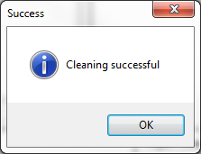

Errors and Warnings

1. If you select a root drive folder (e.g., C:\, E:\, F:\) you will see the following warning.

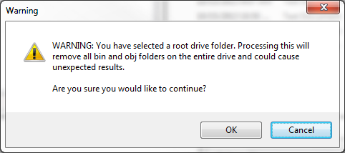Note: “Cancel” is selected by default to prevent accidental confirmation.

1. If a file is in use, you will see the following message.
   1. **Try Again**: Re-attempts to delete the file
   2. **Cancel**: Skips this file and continues the cleaning process.
2. 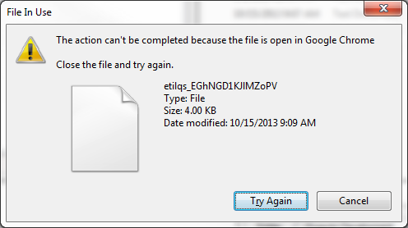If you attempt to run the cleaner without selecting a file, you will see this:

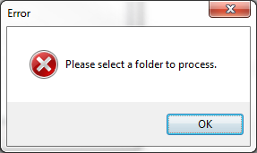

1. If a file path is selected folder directory is incorrectly formed or does not exist, you will see this:

